Total A Units Rec:
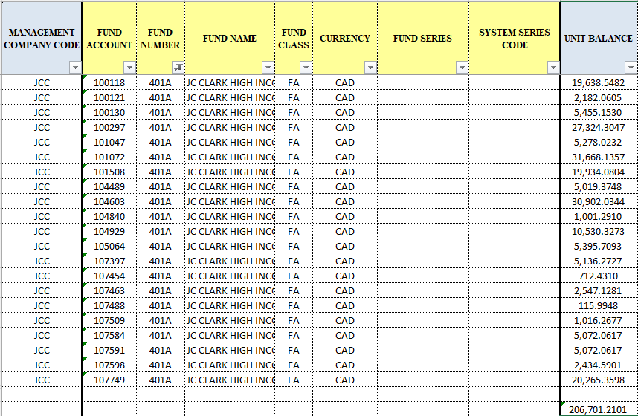
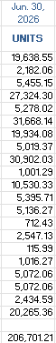
Spot check pricing:

